Weathering and Erosion
Agents of Erosion-
- Ice
  - Glaciers create u-shaped valleys
  - Leave behind unsorted sediments
  - Cause striations
  - Leave behind features as moraines, kettle lakes, drumlins
- Water
  - Create v shaped valleys
  - Leave behind sorted, rounded sediments
  - Form features like meanders, deltas, floodplains, oxbow lakes
  - Oceans-longshore drift
  - Longshore currents, waves, tides
- Wind
  - Occurs mainly in areas of little vegetation b/c roots hold soil
  - Created sand dunes
- Gravity
  - Landslides aka mass wasting or mass movement-gravity>friction keeping sediments in place
  - Talus-sediments found at base of a landslide
  - Different types of mass wasting, by speed and conditions
    - The creep-slight, slow movement of soil
    - Slump-slow movement, large chunks of beadrock slide down
    - Debris flow-rapid downslope flow of debris
    - Mud flow- downward flow of fine particles and larcge amounts of water
    - Avalanche-faster than flow, dealing with ice or snow
    - Rock fall- rapid falling by sleep cliff
How Does Soil Form?
- soil=loose mixture of rock fragments, organic matter, water, and air
- soil begins when bedrock is weathered
- organisms live among the weathered pieces → organic waste
How is Soil Biotic?
- Living things break down the remains, makes humus-needed by plants to grow
- Worms etc loosen material for water and air drainage

What is a soil horizon?
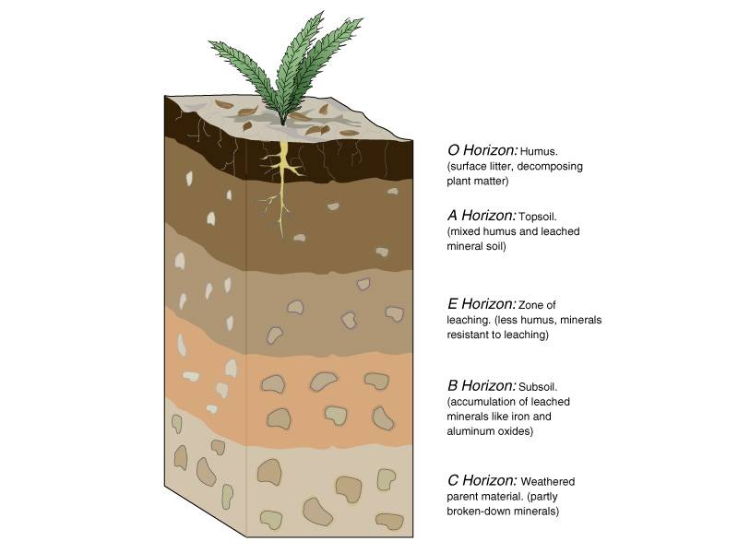
(ignore E)
What are some Soil Characteristics?
- Soil Texture, sand-silt-clay (Largest-smallest)
- Color-depends on what minerals or organic matter is present
- Soil pH-measure of acidity of the soil
- Pore space-spaces between soil particles, water and air are found in the pores
- Soil fertility- how well a soil can support plant growth

