- What is the relationship between craters, calderas, vents, and magma?
  - Lava erupts trough the vent. The crater is a bowl shaped depression at the top of the volcano. Calderas are larger depressions that are formed when the summit or side of the volcano collapses. Magma is the molten rock that flows in the earth. When Magma breaks the Earth’s surface, it is called lava.
- How does a crater lake form? (words and pictures)
  - A crater lake is formed when the summit or side of a volcano collapses into the magma chamber that once fueled the volcano
- What two factors does a volcano’s appearance depend upon?
  - The type of material that forms the volcano and the type of eruptions that occur
What characteristics vary among volcanoes?
- Size, shape, and composition
Complete the following table in your notes:
Type of Volcano | Materials & Description | Sketch | Example
Shield | Basaltic lava accumulates from nonexplosive eruptions  http://gigantesdomundo.blogspot.com/2013/04/o-maior-vulcao-do-mundo.html | 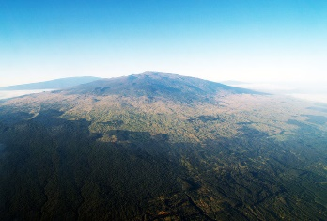 | Mauna Loa
Cinder-Cone | Highly ejected material falls back to earth, piling around the vent. Magma contains more water and silica and erupts more viciously | 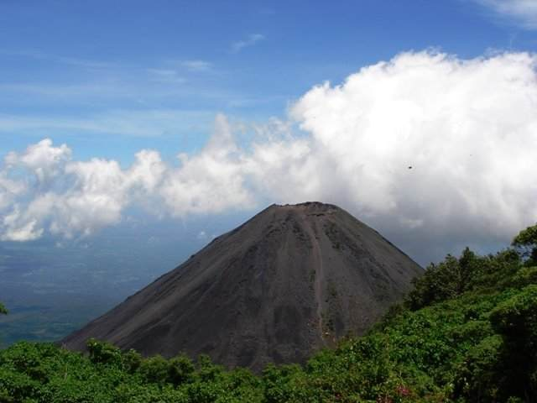  http://www.panoramio.com/photo/3550875 | Izalco in El Salvador
Composite (Stratovolcano) | Layers of volcanic fragments alternate with lava. Magma contains silica, water, and gases. Most explosive and dangerous | 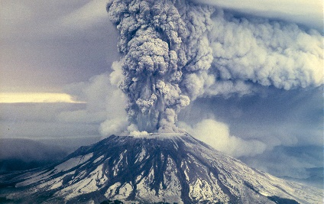  http://www.oregonlive.com/mount-st-helens/ | Mt St Helens

- How do the volcanoes compare in terms of size and slope? Shield volcanoes are the largest and have the shallowest sides. Cinder cone volcanoes are the smallest and have the steepest sides.
- What factors cause differences in size and slope? Difference in materials, vegetation, local climate, and eruptive history
- What is tephra? Rock fragments thrown into the air during an eruption
- What is a pyroclastic flow? Rapid movement of volcanic material, has the potential to kill many people and cause much damage
- Where are most volcanoes found? Ring of Fire
Use the maps provided to show: (1) the Circum Pacific Belt and the Mediterranean Belt where convergent volcanism occur and (2) the Hawaiian Emperor Volcanic Chain.
- How do hotspots form? Hot regions of Earth’s mantle have high-temperature plumes of mantle material that rises toward the surface
- What do hotspots tell us about tectonic plates? They provide information about plate motions
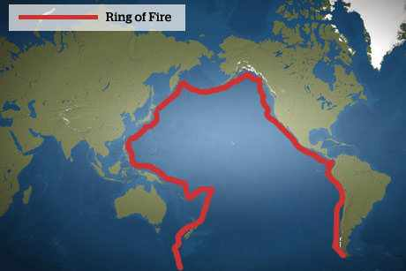
http://secondcomingherald.com/2013/02/four-strong-earthquakes-signal-an-angry-ring-of-fire

