

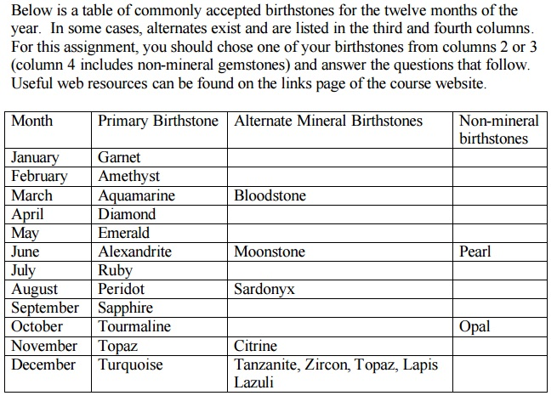

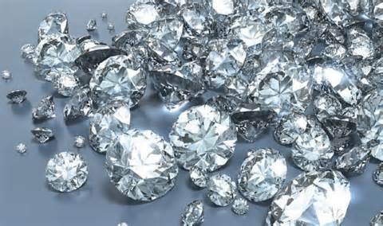

My mineral/ Birthstone is Diamond

Chemical Formula: Carbon, covalently bonded with no free electrons

Color(s): Colorless

Streak: None

Hardness: 10

Luster: Adamantine

Specific Gravity: 3.52

Cleavage: perfect in four directions

Fracture: Conchoidal (shell-like)