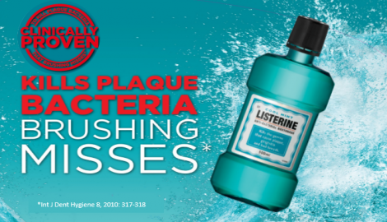
Independent Variable: The use of Listerine mouth wash
Test Group 1: Brush teeth and use Listerine | # of Trials: 10
Test Group 2: Only brushes teeth | # of Trials: 10
Control Group: Neither brushes teeth or uses Listerine | # of Trials: 10
Dependent Variable: Amount of plaque found after subject has competed their task(s)
Constants: Same type of tooth brush, same tooth paste (and amount), same amount of Listerine

Hypothesis: The subjects who both brush their teeth and use the Listerine will have less plaque remaining on their teeth.

- Observations - Listerine claims to kill plaque that is missed by brushing alone
- Question – Would a subject who brushes and uses the Listerine have less remaining plaque?
- Hypothesis - The subjects who both brush their teeth and use the Listerine will have less plaque remaining on their teeth.
- Experiment – Each test group will follow the directions listed above. Afterwards, have each subject use a plaque-detecting tablet (https://www.nlm.nih.gov/medlineplus/ency/article/003426.htm) and check for plaque remaining on the subjects’ teeth, rate each subject on a scale of 1-10
- Data collection and analysis – Create a graph to represent your data. In theory, the data should show that the subjects who used the Listerine had the least plaque, followed by the subjects who only brushed, followed by the control group who neither brushed nor used Listerine.
- 10 subjects are used in each test group to achieve the “magic number” of 30 subjects, as found in statistics. Having at least 30 subjects ensures that your data is representative of the population.

