Attractions and More!  Attractions in the Taiga include: skiing, forest nature trails, rafting and canoeing, and snowshoeing. Your attire should reflect which season you are in. During the summer months, light and casual clothing such as shorts are recommended. In the winter, however, dress with multiple layers and bring a heavy coat! Tempurture in the Taiga fluctuates greatl through the seasons, so be prepared. |  | - “Boreas” was the Greek name (and Greek God) for the North Wind  - The biome is prone to wildfires  - The taiga covers 11% of the Earth  - Trees grow taller where the taiga is warmer  - Decomposition is slow, dead vegetation can pile up on the ground  - There are fewer animal and plant species than other biomes  - Trees have adapted to become more wildfire resistant  - The trunks of trees are used to make paper  - Some of the world’s oldest trees can be found in the taiga  - Scientists believe that the taiga was once covered in glaciers | Fun Facts |  | Taiga  - “It’s pretty chill here”  Mamie Frank  Earth and Environmental Science  Mr Dillman

Köppen Classification  The Taiga is classified as DFC or DFD, with severe winters and tempuratures that range from -3C to 10C.  Average Daily Precipitation  Winter: .16 in  Summer: .5 in | Average Daily Temperature  Winter: -27C  Summer: 8C |  | Flora  Siberian Spruce- waxy coating on the needles that protect from drying winds and dark green needles that expedite photosynthesis  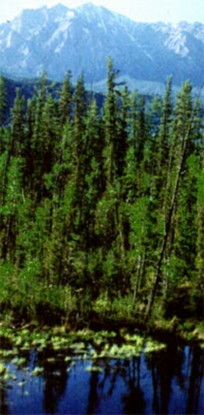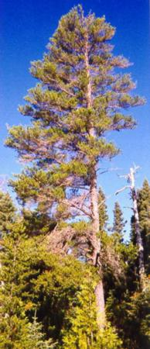  Jack Pine-Rough bark to protect from animals and wind, slender twigs that prevent snow from adhering  Fauna  American Black Bear- Thick shaggy coat to protect from the winter, claws just right in length to climb surrounding trees  Snowshoe Rabbit-fur on the bottom of its feet protect it from snow covered ground, its toes act like snowshoes

